Technology and Systems: Technological Systems Model
Technological systems are the building blocks of technological products. A system is designed to produce a specific output. A microwave oven, for example, is deigned to heat things. When you use it to send microwave energy through food, the energy excites the water molecules in the food, causing them to heat up. This heats the food.
Systems have three major parts
- Input, which is the desired result plus the resources used by the system
- Process, which is the action that the system performs
- Output, which is the results of the system process
This basic system model looks like this

Figure Basic System Model
You read the model from left to right. The input is processed to create the output. A Microwave oven is illustrated below
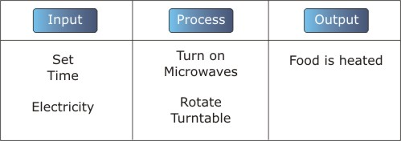

Figure Microwave as System

System Outcomes
As a result of the processes that the system applies to the input, an output is produced. The output may be just what we wanted, or it may not be. It may be just what we expected (not necessarily the same as what we want), or it may not be. We describe this as the outcomes or consequences. Outcomes may be good or bad, expected or unexpected.
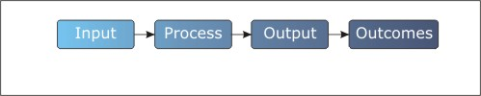

Figure System Model with Outcomes
In the example of the microwave, a number of outcomes are possible. A few are: the food may not get hot enough, it may get too hot, it may dry out, it may be just right, or it may have a bad taste.
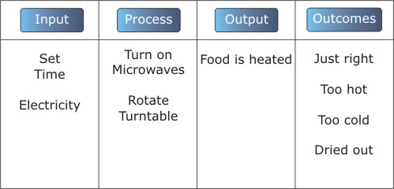

Figure Sample System Outcomes for Microwave

System Feedback
The systems described above have no way of knowing the results of their output. Remember that one of the inputs to the system describes what the system should output. That's where feedback comes in. Feedback is a part of the system that monitors the output, compares it to the input, and adjusts the process to make sure the output is correct.

Figure Systems Model with Feedback
Feedback is used to automatically adjust the system so that the output is what is required.
Lets look at electric heat in a room as an example of a system with feedback. Electric heat usually has a thermostat, either on the wall, or on the heater itself. The thermostat is really three devices.
- One is a dial (or slider) setting you adjust to tell the system your desired temperature.
- The second is a thermometer that measures the actual air temperature.
- The third is a switch that turns the heater on and off.
The switch is actually controlled by the thermometer. The on-off point is set by rotating the dial. When you rotate the dial to 20 degrees, you also set the thermometer/switch combination so that when the temperature drops below 20 the heat turns on and when it rises above 20 it turns off. The thermometer is the feedback device. It constantly tells the system if the temperature is correct and turns the heater on and off to bring it to the correct temperature.
The heating system is described below, with a few possible outcomes
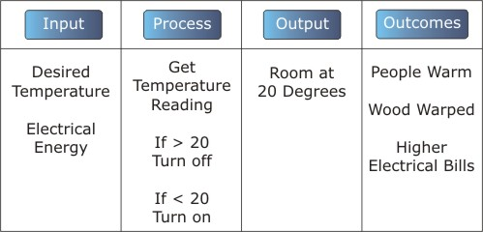
Figure Electric Heating System

Open and Closed Loop Systems
Now that you know the difference between a system with feedback and one without feedback, you know the difference between open and closed loop systems.
- An open loop system has no feedback
- A closed loop system has feedback
Closed loop systems are also control systems. They are used to control and manage processes so that they operate within preset parameters (rules).

