Visual Design
Visual design is the art of presenting something visually. The visual presentation usually has a purpose and a function. Particularly in interface design, the designer wants the user to quickly and easily understand the purpose and function of the design. Consider a vehicle instrument panel, a remote control layout, or a piece of software.

Elements of Visual Design
The elements of visual design are the building blocks that make up the design.
- Line. Lines can be made directly (for example a painted line), or indirectly (for example when a group of objects are aligned so that you get the impression of a line)

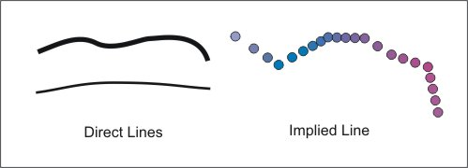
Figure Lines
- Shape. A shape is a completely closed two dimensional area. Shapes may be directly defined by lines, or may be implied by the positioning of other objects.

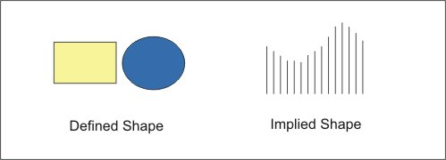
Figure Shape
- Form. Form is a completely closed three dimensional object. It may be defined or implied.

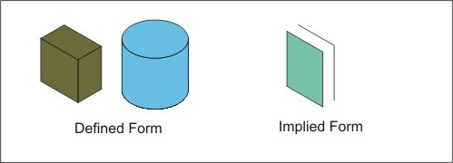
Figure Form
- Direction. Horizontal gives the feeling of calmness. Vertical gives the feeling of balance and formality. Angled gives the feeling of movement

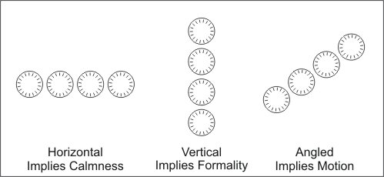
Figure Effect of Direction
- Size. The area occupied by a shape or form. Usually it is considered relative to the size of other objects.

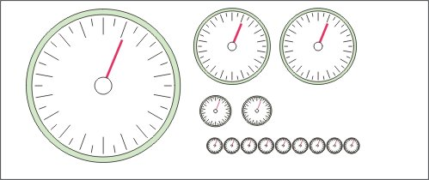
Figure Size is Relative
Larger sizes can be used to indicate relative importance of an object. Larger objects seem to advance towards us and smaller ones seem to recede away from us.
- Texture. Texture is surface appearance and feel. Compare, for example, the texture of a glass and a towel, a knife handle and a steering wheel, a plastic laminate counter top and a leather seat (or shoe). Texture serves a very specific purpose when the device has to be manipulated or if the visual appearance denotes a meaning.

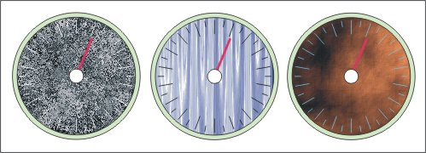
Figure Effects of Texture
The textured dials affect the readability of the instrument. Compare them to the plain dial above. Which is easiest to read? most difficult?
- Colour. Colour is a complex issue. There are 2 sets of primary colours, depending on how they are created.
  - Additive colours are created when we mix emitted light, for example from the sun, a light bulb, or different LEDs. Additive primaries are red, green and blue. All the TV and computer images we see are made up of these 3 primaries.
  - Subtractive colours are created when we mix materials that reflect light, for example different coloured paints or dyes. Subtractive primaries are cyan, magenta, and yellow. Inkjet printers use subtractive colours. A fourth ink, black, is added because it is difficult to create pure black from a mix of the 3 coloured inks. Cyan, Magenta, Yellow, and Black are called CMYK. All the colours of inks, paints and so on that are used to colour the objects we use every day come from these 3 primary colours plus black.
Colour affects how we perceive things. We see red as danger, for example. One colour against another affects how we see both colours.

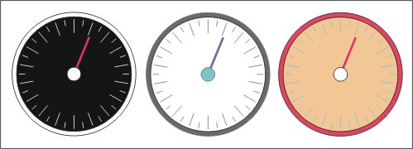
Figure Effects of Colour
Colour also affects legibility. Compare the dials to the plain one above. Is one more legible than the others?
- Value. Value is the lightness or darkness of an object. It is really the amount of black or white in the colour.

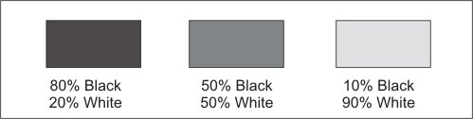
Figure Value as Percentages of Black and White
The center grey is neutral.

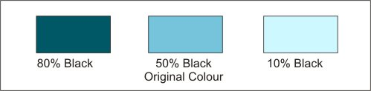
Figure Effects of Value on Colour
The darker colour is considered a shade. The lighter colour is considered a tint.
Value is a frequently used element in visual design. Compare the dials below. The first uses the same colour throughout, changing the value to provide visual discrimination. The second uses multiple colours, each with the same value. The black and white version uses the ultimate value range.

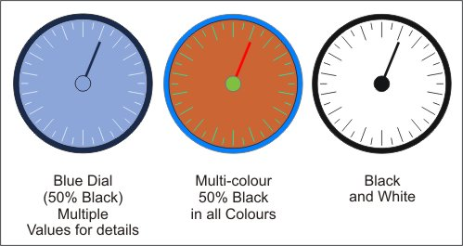
Figure Effects of Shade on Visual Discrimination
As you can see, the highest level of visual discrimination occurs when the greatest difference in value is present. Despite the first example, use of different values of a single colour can provide high levels of visual discrimination. Likewise, use of multiple colours can be very effective, but work best when each is a different value.
The difference in value from darkest to lightest is known as the contrast range.

Principles of Visual Design
The principles of visual design determine best practices for combining the elements into a particular visual arrangement. They are
- Balance. Balance is the visual weight of the left and right halves of the design. Lower value (darker) seems heavier, higher value (lighter) seems less heavy. Likewise lighter colours seem lighter than darker colours.

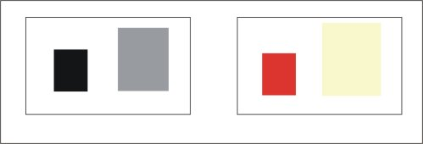
Figure Informal Visual Balance
In both cases above, the visual weight of the figure on the left balances the larger figure on the right. These are examples of informal balance. Formal balance occurs when both sides are identical.

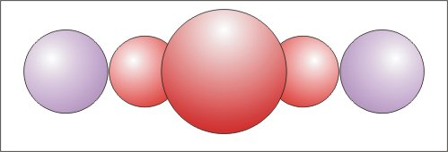
Figure Formal Balance
These principles are applied to the design of interfaces like automobile instrument panels, for example.

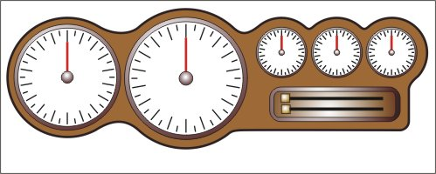
Figure Instrument Panel Design
What type of balance is used here? Can you identify the different elements of design at work? To see professionally designed instrument panels, look at auto maker websites, or aircraft maker websites.
- Contrast. Contrast is used to distinguish one element of a design from others. Contrast can be achieved with different colours and values placed in close proximity, as in the instrument panel above. Contrast can also be achieved with different orientations and types of elements, for example horizontal/vertical, or circles/rectangles. High contrast enables high levels of visual discrimination between elements.

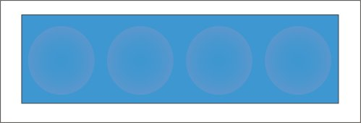
Figure Low Contrast

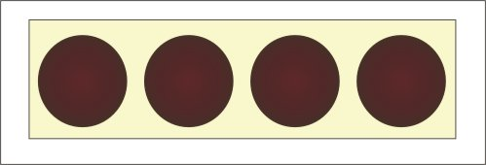
Figure High Contrast
High contrast is essential when the interface displays critical information for the user.
- Proportion. Proportion is the ratio of the sizes of one element with another. Good proportion makes the design visually pleasing. Proportion can be applied to a single element (height vs. width) or to an entire design (proportion of all elements to a major element).

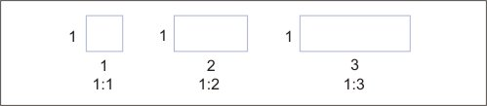
Figure Proportion as a Ratio Between two Sides
- Pattern. Pattern is the use of repeated elements for visual effect.

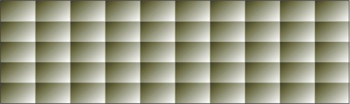
Figure Pattern
- Gradation. Gradation is the gradual transition in value across an object or a series of objects.

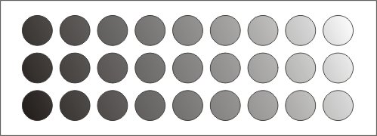
Figure Gradation from Black to White
- Proximity. Proximity refers to the practice of grouping related objects close together, or of giving objects that are close together similar characteristics.

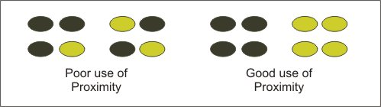
Figure Proximity
- Alignment. Alignment is used to make it visually easy to find information. Different styles may be used, for example horizontal, vertical, angled or curved. Try to read each gauge in turn in the figure below. Which set is easiest to read

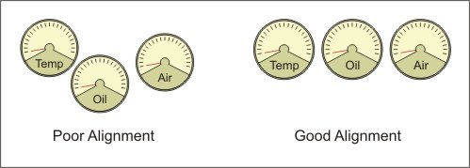
Figure Alignment
- Repetition. Repetition is the repeating of a visual element or property. Use of a specific colour and type of trim on all the seats in an airplane is an example of repetition. Repetition ties different parts of an object together. In the airplane example, floor, wall, and ceiling coverings would also include repeating trim properties.

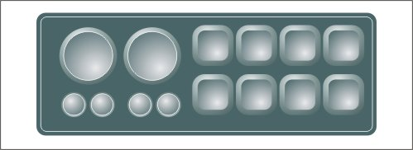
Figure Repetition of Colour and Shape
What other principles are at work in this figure? Can you identify the elements?
- Unity. Unity is the use of all the elements and principles of design to achieve a sense of 'wholeness' of the design. Unity occurs when everything contributes to this sense of wholeness. Good use of colour, pattern, and from contribute to unity. Look at the images on this page. Which ones give you an impression of unity? What elements and principles contribute to this?

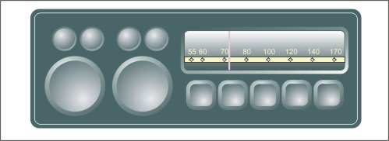
Figure Unity

Interaction Design
An interface is built to facilitate interaction, or a two-way exchange between humans, or between humans and technological devices. For interaction to take place, the person needs to have choices, have control over the exchange, and must take an active role in the exchange.
Interaction design is the design and development of interfaces that let humans interact with one another and with their devices or tools. Interaction design can apply to any device that people use.
Tools, whether physical (shovel) or virtual (software), are designed for people to use. People interact with them. The design needs to be obvious and related to the purpose of the tool, and how the tool is used. Microsoft (User-Centered Design Principles), advocates these principles of interaction design.
- User in control. The use should always feel in control. The user should initiate the actions. As well, users should be able to personalize the interface.
- Directness. The interface needs to directly represent the process or action that it is initiating or emulating. In the video clip below, look at the dials on the computer screen. When they are moved with a mouse, the corresponding motor rotates an equal amount.
- Consistency. Consistency is using controls, features, and colour coding in the same way all the time. This allows people to use what they've already learned in new situations.
- Forgiveness. Forgiveness is the practice of only presenting usable, useful information in the interface and allowing users to discover new features without getting lost or doing something wrong. If the interface controls a critical function for example, you want to warn the operator if the action being taken will have a detrimental effect. Usually a warning is presented and an option to cancel the request is offered.
- Feedback. The interface should provide feedback on the users actions. Feedback informs the user if the action was appropriate, if the requested action is being performed, and if something additional needs to be done. A speedometer in a car is an excellent example of a feedback device. It lets you know how fast you are going and directly and immediately reflects the actions of the two main controls—the accelerator and the brake.
- Aesthetics. Aesthetics refers to the way the attributes (elements and principles) of visual design were applied to the interface. Good aesthetics provides a visually pleasant, stimulating interaction experience. It ensures that visual elements in a design (all of which compete for the users attention) contribute to the usability of the interface.
- Simplicity. The interface should be simple, easy to learn and easy to use. This requires a balance between simplicity and functionality. The simpler the interface, the fewer functional elements are present. Making it too simple makes it less useful. Using familiar objects can simplify the interface. For example, if the interface is a control panel for a fire truck's ladder, the symbols and controls used need to reflect the actions of tilting the ladder up/down, rotating the base of the ladder clockwise/counterclockwise, and extending/retracting the ladder. Likewise, if you are building a software interface to control a model plane, you need appropriate symbols to control ailerons and flaps.

Assigned activities
The purpose of this activity is to explore interaction design
- Find 10 devices (any size or function from a pencil to an airplane) that you or someone else uses regularly. Identify the purpose of the device, and the controls or mechanisms used to operate the device. Using the 7 principles of interaction design in the lesson, assess the interaction design
  - rate each device on each principle from 1 (poor) to 4 (good), using a table like this one

Device | Interaction Design Principles
Device | 1 | 2 | 3 | 4 | 5 | 6 | 7

Interface Basic Concepts
There are many forms of interface. There is a commonality among them. Generally speaking, they are what connects two dissimilar materials, devices, systems, or processes so that they can work together. Under ordinary circumstances these things would not interact with each other. The interface makes interaction possible.
Technology is the human constructed world. It gives us the tools and processes to do things. In a very broad sense, technology is the interface between people and many of their actions—at work and at play. It is used to modify our environment, for example, to allow us to live in inhospitable places.
Most of the time we restrict the definition of interface to more specific meanings. A few of the definitions/descriptions are
- In hardware, an interface is a connector used to link devices. In software, it allows communication between two software systems or between people and systems www.libraryhq.com/glossary.html
- An interface is
  - A shared boundary. A physical point of demarcation between two devices where the electrical signals, connectors, timing and handshaking are defined.
  - The procedures, codes and protocols that enable two entities to interact for a meaningful exchange of information.
- In relation to human communication with a computer, the appearance of the screen via which the interaction occurs. www.eupen.com/glossary/glossarycable.html
- A shared boundary across which information is passed. A hardware or software component that connects two or more other components for the purpose of passing information from one to another.
There are two general categories of interface that we are concerned with
- Human-machine interfaces. Human machine interfaces allow people to talk to machines. The interface translates information from the machine into something we can understand, and translates information from us into language the machine can understand.
- Machine-machine interfaces. Machine-machine interfaces allow machines to talk to one another by converting the signals that one understands into signals that the other understands.

The Human to Machine Interface
Human-machine interfaces are all around us. We use them everyday. Essentially any device or mechanism that we use has an interface. There are handles, grips, knobs, levers, pedals and the like. All are made (or should be!) so that we can use the device effectively and efficiently.
One of the labels we give human machine interfaces is the Human Interface Device or HID. The Human Interface Device is any physical device that a person can manipulate directly, thereby providing a means to control or manipulate a system. Keyboards, mice, joysticks, graphics tablets, and other pointing devices are all HIDs to provide input to a computer. So are touch screens on banking machines, and control panels on gas pumps at the gas station. Essentially, any interface designed for human use is an HID. The label is used particularly for input devices for computers.
Examples of human to machine interfaces include
- Appliance Controls. Household appliances have a physical interface. This is the control system that enables you to operate the device. The picture below shows the main interface on an older computerized sewing machine. Each button has a dedicated function. Newer versions of the same machine have a more sophisticated computer and use a touch screen for control, eliminating most of the physical buttons.

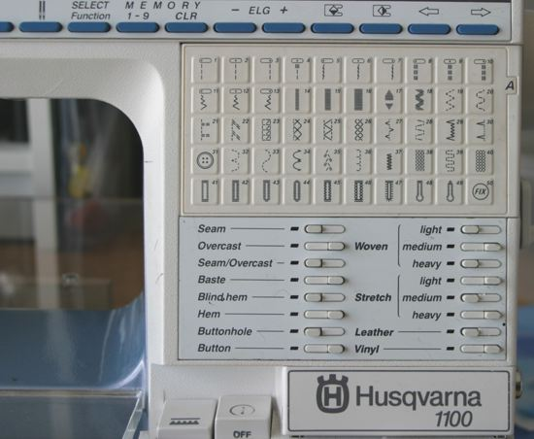
Figure Physical Interface on Sewing Machine
- Remote Controls. Remote controls that you use every day are an interface between the mechanical action of pressing a button (making a selection) and causing an action occur on the electronic appliance. The remote converts mechanical action into signals that can be used by the TV, DVD, or Receiver. Most remotes send the signal as a series of pulses over infrared light, although some use radio frequencies. A sensor on the TV reads the pulses and converts them into electrical signals that the TV logic can use. Some remotes use radio waves to send signals. These are the ones you can take anywhere in the house.

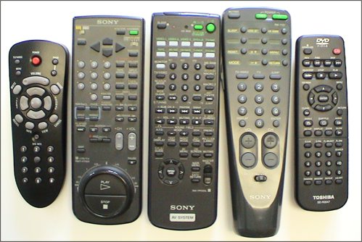
Figure Remote Controls as Interfaces
- Telephones.

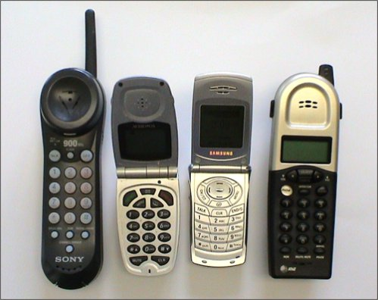
Figure Telephones as Interfaces
- Computer Input/Output. Any device that lets us send input to, or get output from, a computer is a human to machine interface. Keyboards, mice, graphic tablets, touch screens, and joysticks are all input devices. Monitors, printers, plotters, and speakers are all output devices.

The Machine to Machine Interface
Machine to machine interfaces enable one machine to send information to another or allow one machine to control other machines. Machine-machine interfaces were invented to allow automation in cotton mills and other manufacturing processes. Initially they were mechanical devices depending on gears, levers and pulleys.
The Jacquard Loom, invented in 1805, got its instructions for weaving complex patterns from holes punched into cards. Babbage invented the analytical engine in the 1830's (a general purpose analog computer) using gears and levers. It was programmed with punched cards. Babbage's engine was also used to control looms. In the case of the loom, the instructions stored on punched cards or paper tape were translated by the analytical engine into a series of mechanical movements of the gears, pulleys and levers. These in turn set up the correct positions of the various parts of the loom so that the cloth was woven with the desired pattern. The interface converted the hole pattern into mechanical actions that operated the loom. Prior to this technology, all this was done by hand.
Over time machine-machine interfaces moved from being mechanical to fluidic/mechanical (using pressurized air or hydraulic fluid with mechanical components) and then to electrical/mechanical, and finally computerized. In all cases, the interface takes information (from a person or a machine) and translates it into information that the other device can use.
Computers and computerized equipment use many types of interface. A typical home computer may have
- A PS2 port for keyboards or mice
- A serial port
- A parallel port
- USB ports (Universal Serial Bus)
- Firewire ports
- NTSC video or S-Video port
- VGA Port (SVGA, XGA, etc)
Most of these interfaces support data going into and out of the computer. Depending on the device attached, and the program being run on the computer, the interface port can be an input or an output device, or both simultaneously.
Computers are used in most modern machinery and equipment, and in all sorts of vehicles. In all cases, interfaces are used to collect information from the equipment and the environment around them, and to send information back to control the equipment or environment. Examples include
- Cars. Cars have sensors for atmospheric pressure, fuel flow, exhaust emissions, and other vehicle data. Interfaces convert the data into signals used by the car's computers to manage ignition timing, spark, fuel flow, and other operating parameters. In addition, a data port connected to the Powertrain Control Module on cars is used to connect an external reader to the vehicle's onboard computers. The computers collect data about the vehicle's condition which is used by technicians to determine how to service the vehicle. This example shows how the port is used with a laptop computer to collect and interpret the data. Other tools let you reprogram the vehicle's computers for different operating conditions. On some vehicles, for example, when the transmission oil is changed, the transmission needs to be reprogrammed before you can drive the vehicle.
- Ships. Ships, like the Joseph and Clara Smallwood, have onboard computers. These are interfaced to a variety of inputs and outputs on the ship. Using the GPS Navigator, the Captain can, for example, set engine speed in RPMs, set engine speed by fuel consumption, set engine speed by rate of travel through the water (Knots per hour), or set engine speed by setting the desired arrival time at the destination. The ship's computer, through various interfaces, sets rpm rate and fuel consumption to meet the settings input by the Captain.

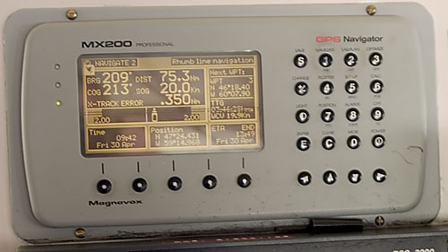
Figure GPS Navigator reads data from a variety of sensors and controls engine and rudder settings
- CNC Machinery. Computer Numerical Control machines use an interface that translates the geometry of a technical drawing into the actions of the machine. Metal (or other material) is automatically positioned and cutters operated to remove the desired amount of material based on the specifications from the drawing. CNC Lathes and Mills are typical of this type of machinery.

Interface Components
Interfaces may be constructed from physical components and virtual components. All interfaces have a physical component. Some have a virtual component. If they are human machine interfaces they have a visual component.
- Physical component. These parts of the interface consists of physical devices. Examples are
  - A MODEM (modulator/demodulator) used to convert computer signals such that they can be carried by phone lines (modulate), and convert incoming signals back into computer signals (demodulate). All modems do this, including DSL modems and cable modems (for transport over coaxial cable).
  - The controls on a vehicle such as the gas pedal, brake, steering wheel and dashboard instrumentation used by a person to control the vehicle on the road
  - The controls on kitchen appliances such as stoves, microwave ovens, and toasters used by a person to control the appliance
- Virtual component. A virtual component is one that exists only in code in computer memory or on a chip. If there is a human interaction function, the results may be displayed via electrical signals on a monitor or some other output device. Operating systems, software, and television are virtual interfaces. What you are viewing only exists while the signal is being displayed on the monitor. Examples are
  - A computer operating system. It communicates with the various system devices such as the CPU, memory, hard drives and keyboard. It allows you to communicate with the computer. It sits behind the graphical user interface you see on screen.
  - The program in your cell phone that allows it to display on its screen the number you type, and translates your voice into digital signals and sends them out via the built in radio.
- Visual Component. These are elements of interfaces that convey information to the user and allow the user to interact with the system. Any physical interface that will be directly managed by a person will have a visual interface. Even those that are not used directly by a person often have visual interfaces to indicate the current status of the device, for example the status lights on an 802.11G Wireless Router. Other examples are
  - The use of lights in the traffic signal system in Canada. We use red, yellow, and green lights placed in a specific location and orientation to control traffic flow on streets. Vehicles have white, amber, and red lights in specific locations which are used for specific purposes to indicate their status and intentions. Emergency vehicles have additional indicators.
  - Virtual interfaces have visual interfaces. The visual interfaces for operating systems and software allows the user to interact with the system. Windows, Mac OS X, and KDE and Gnome for Linux are examples of visual interfaces that sit on top of virtual interfaces (software operating systems)
  - Television has its own forms of visual interface. News shows, sitcoms, and other shows are instantly recognized by the visual arrangement of the set.
You have probably deduced from the few examples above that all three of these components generally co-exist.

